Wazuh Manager VM Setup on Windows Host & Endpoint Policy Configuration

Introduction
In this report, I document the process of setting up a Wazuh Manager virtual machine on a Windows host system and configuring endpoint security policies for monitored devices. The objective of this setup is to gain practical experience with Security Information and Event Management (SIEM) and Endpoint Detection and Response (EDR) using Wazuh. This implementation enables centralized monitoring, log analysis, file integrity monitoring, and threat detection for endpoint systems.
Lab Objectives
- Deploy a Wazuh Manager using virtualization technology
- Connect a Windows endpoint using the Wazuh Agent
- Configure basic endpoint security monitoring policies
- Verify alert generation and system visibility

Phase 1: Configuring the VMware Network
I open VMware Workstation Pro and navigate to Edit > Virtual Network Editor. From the Virtual Network Editor window, I click Change Settings at the bottom right and grant administrator privileges when prompted.
Next, I select VMnet8 from the list of available virtual networks and confirm that the network type is set to NAT. Under the VMnet Information section, I verify that NAT is selected. This configuration is recommended for a lab environment because it allows all virtual machines to communicate with each other and access the internet for updates, while remaining isolated behind a Network Address Translation (NAT) from the physical home network.
Finally, I take note of the Subnet IP assigned to VMnet8 (192.168.59.0), as all virtual machines in the lab will receive IP addresses within this subnet range.

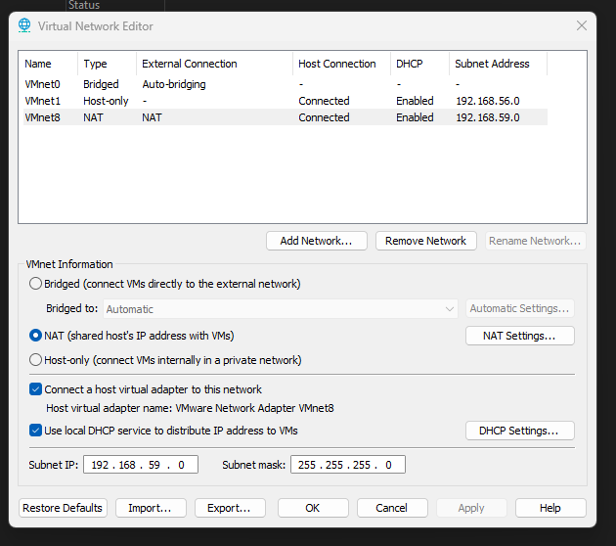
Phase 2: Deploying the Wazuh Server
In this phase, I deploy the Wazuh Server using the pre-built Wazuh OVA image, which is the fastest and most efficient way to get the Wazuh Manager, Indexer, and Dashboard running in a lab environment.
I open VMware Workstation Pro and navigate to File > Open. I then select the downloaded .ova file to begin the import process. During the setup, I assign a descriptive name to the virtual machine, such as “Wazuh-Server,” and choose an appropriate storage location on the host system.
When prompted about OVF specification compliance, I ensure that the virtual machine is allocated sufficient resources, assigning at least 4 GB of RAM and 2 CPU cores to support stable performance. Once the import is complete, I power on the virtual machine.
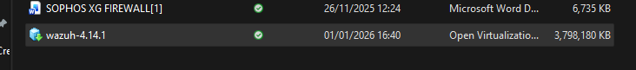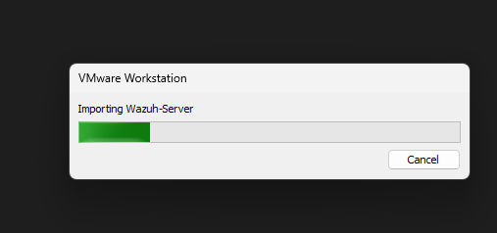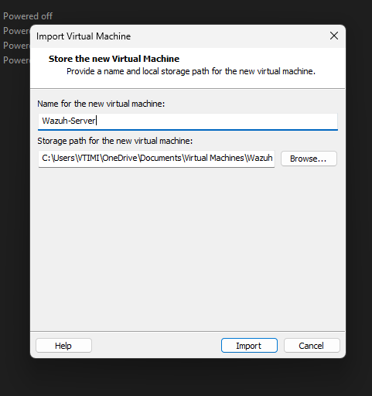
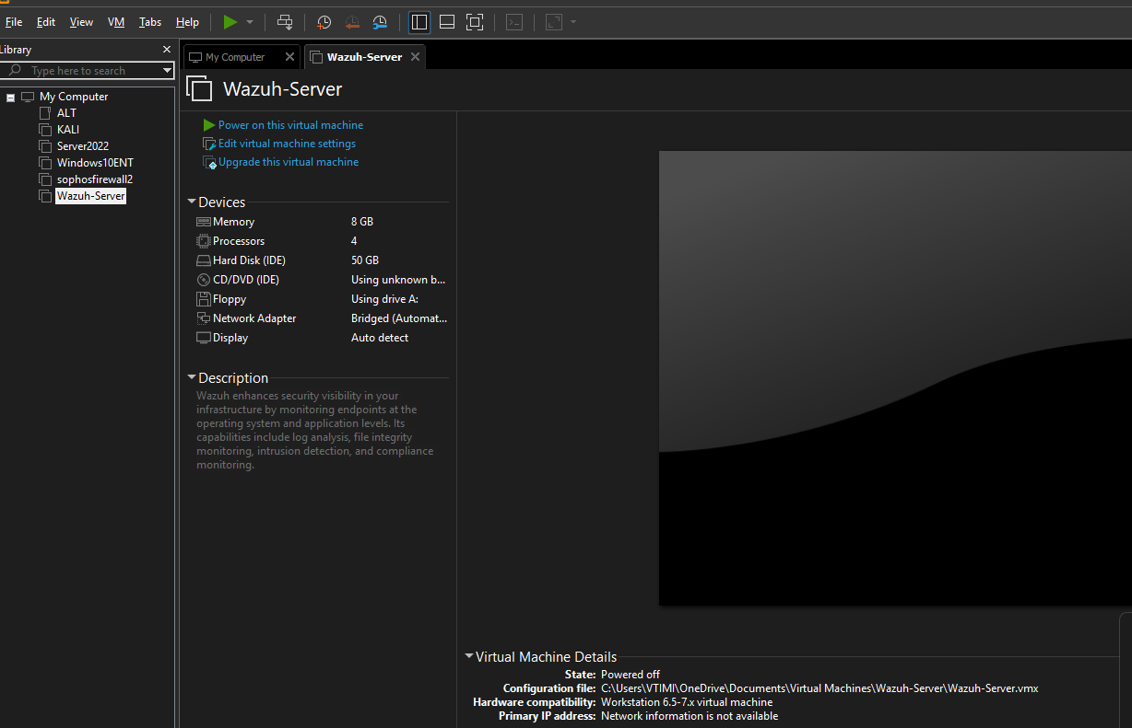
Phase 3: Initial Configuration and Access
After the virtual machine boots, I log in through the VMware console using the default credentials provided on the Wazuh download page (typically wazuh-user / wazuh, as displayed on the login screen or message of the day).
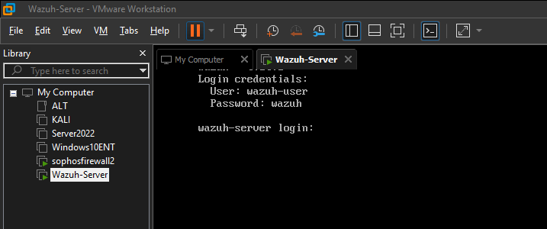

Once logged in, I verify the network configuration by running the command ip a
This allows me to confirm that the virtual machine has received an IP address via DHCP from VMware’s NAT network (192.168.59.0), I record this IP address, as it is required to access the Wazuh Dashboard.
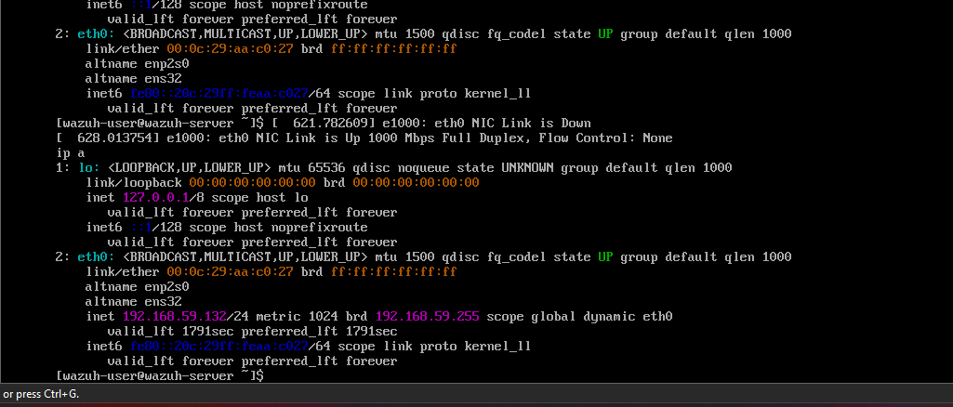

Using a web browser on the host system, I navigate to:
https:// 192.168.59.0
Because the dashboard uses a self-signed SSL certificate, I accept the browser’s security warning and proceed to the site.
I then log in to the Wazuh web interface using the default administrator credentials (admin / admin, or the password displayed on the VM console at login). After successful authentication, I gain access to the Wazuh Dashboard, which provides a centralized interface for managing agents, viewing security alerts, and configuring monitoring and detection policies.
At this point, the Wazuh Server is fully deployed and operational, and the environment is ready for endpoint agent deployment and security policy configuration in subsequent phases.

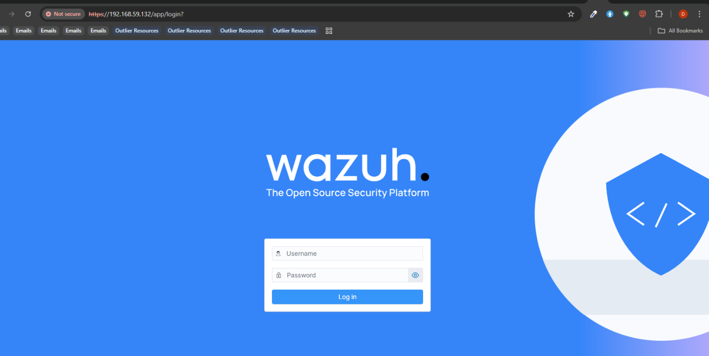

Phase 4: File Integrity Monitoring (FIM)
In this phase, I configure File Integrity Monitoring (FIM) on the Windows endpoint. File Integrity Monitoring is a critical security control and is particularly important for PCI DSS compliance, as it detects unauthorized changes to files and directories that may indicate malware activity or system tampering.
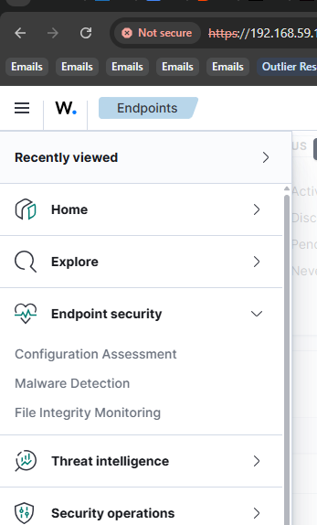

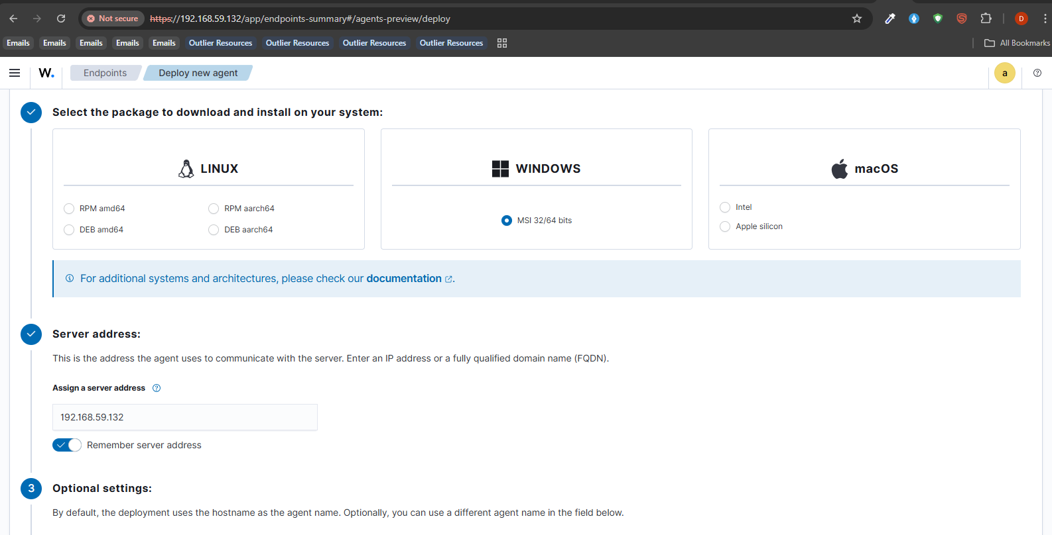

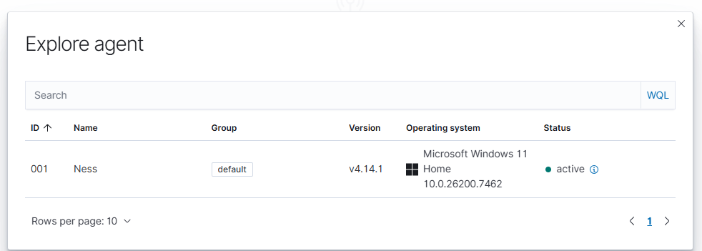

Phase 5: Creating Files and Directories to Monitor
On the Windows agent/endpoint system, I first create a directory that will be used for monitoring. I create a new folder on the Desktop and rename it Assessment II. This folder represents sensitive files that require integrity monitoring.
Inside the folder, I create a text file named Text Doc Wazuh.txt. open this file using Notepad, enter random text into the file, and then close the Notepad window. This file will later be modified to generate FIM alerts and verify that the monitoring configuration is working correctly.
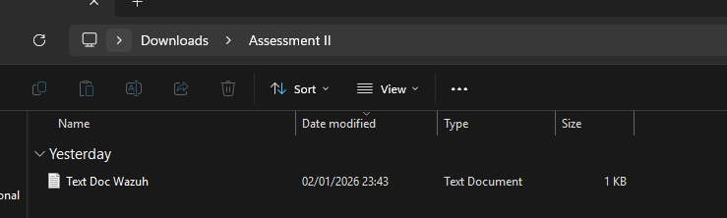
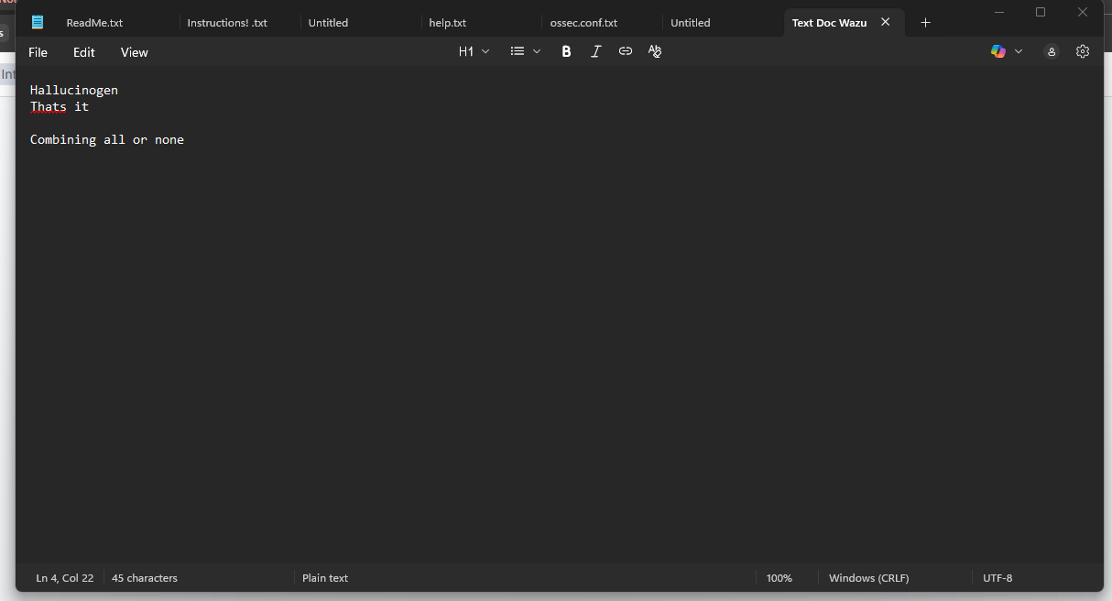
To enable File Integrity Monitoring, I modify the ossec.conf configuration file on the Windows agent.
I open the Start Menu on the endpoint system, search for Notepad, right-click the Notepad icon, and select Run as administrator. This ensures I have the necessary permissions to edit system configuration files.
Within Notepad, I click File > Open to access the file explorer. I navigate to the Wazuh agent installation directory:
C:\Program Files (x86)\ossec-agent\
In the Open dialog, I change the file type filter from Text Documents (*.txt) to All files so that all configuration files are visible. I then locate and open the ossec.conf file.
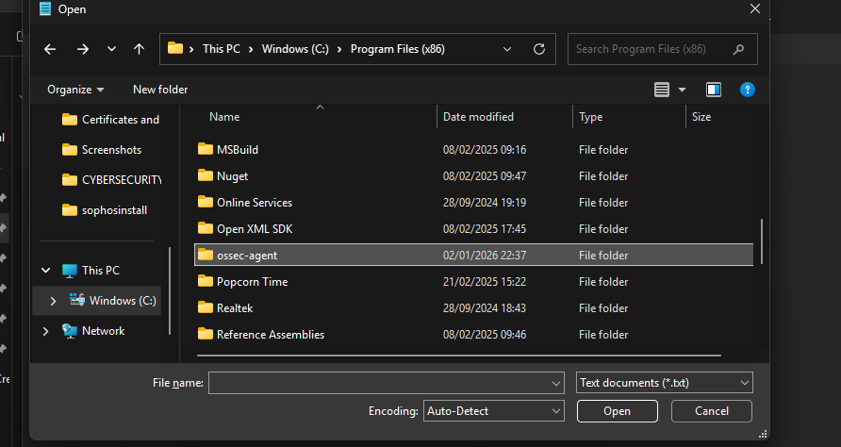

Inside the ossec.conf file, I locate the <syscheck> block, which controls File Integrity Monitoring.
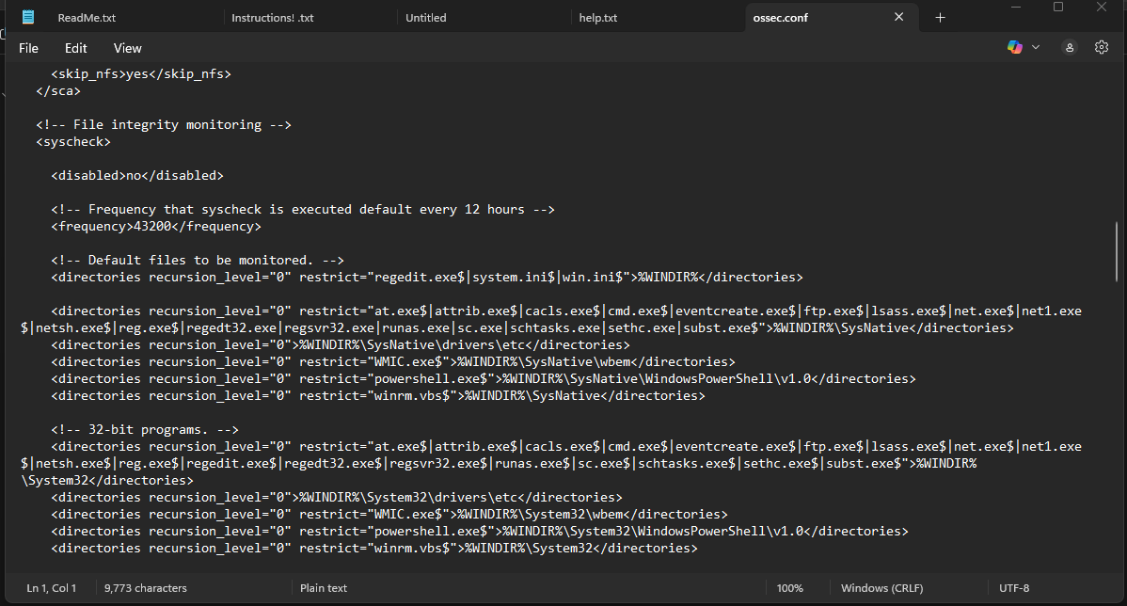
Under this block, I add the directory I want to monitor. For the Assessment II folder, I add the following entry:
<directories check_all="yes" report_changes="yes" realtime="yes">C:\Users\VTIMI\Downloads\Assessment II</directories> 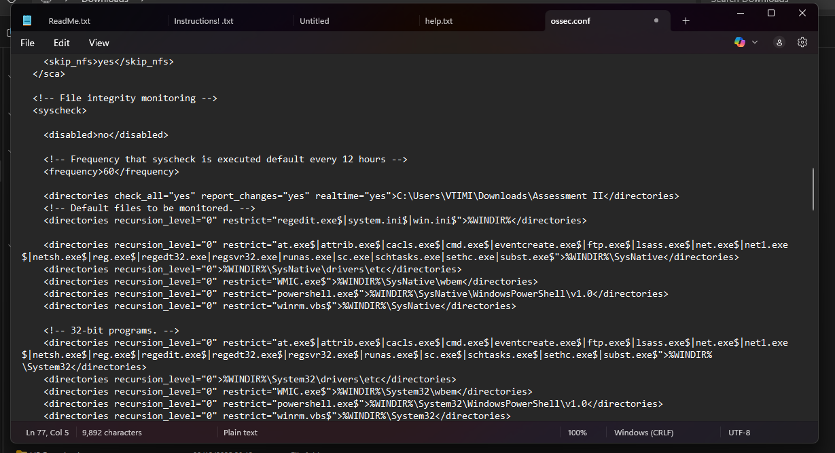
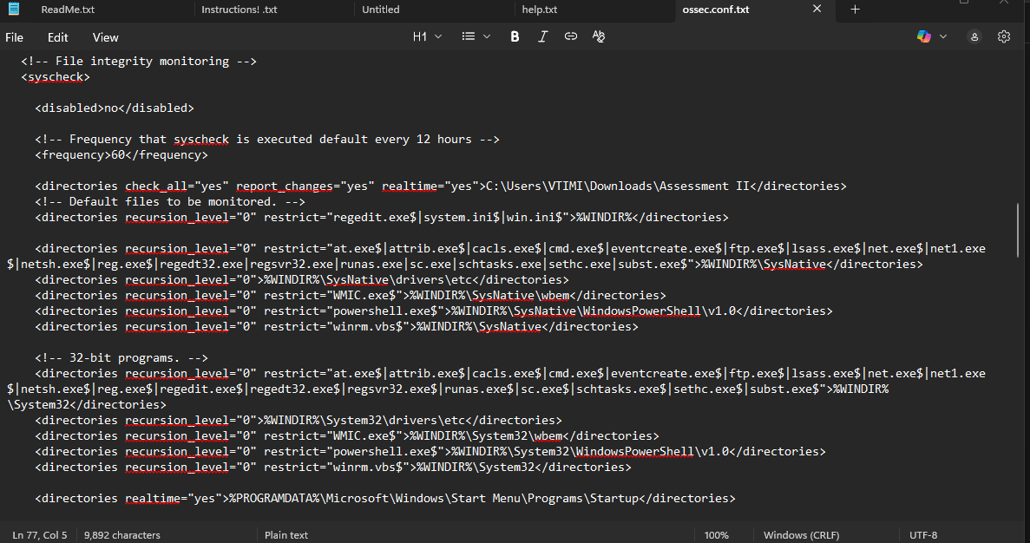
I ensure proper indentation by adding four spaces (or pressing the TAB key once) before the configuration line, as correct indentation is required for the configuration to be parsed correctly. After making these changes, I save the ossec.conf file and close Notepad.
With this configuration in place, I enable the syscheck module, allowing the Wazuh agent to continuously monitor the specified directory for file creation, modification, and deletion events. Any detected changes are automatically reported to the Wazuh Manager, where they are analyzed and displayed as security alerts in the Wazuh Dashboard.
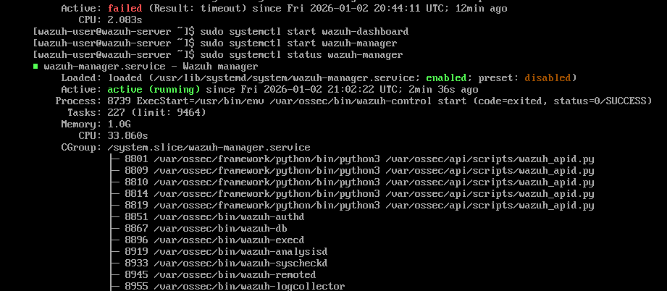
After completing the File Integrity Monitoring configuration, I save the ossec.conf file on the Windows agent. To apply the changes, I restart the Wazuh agent service using PowerShell with administrative privileges by running: Restart-Service -Name WazuhSvc
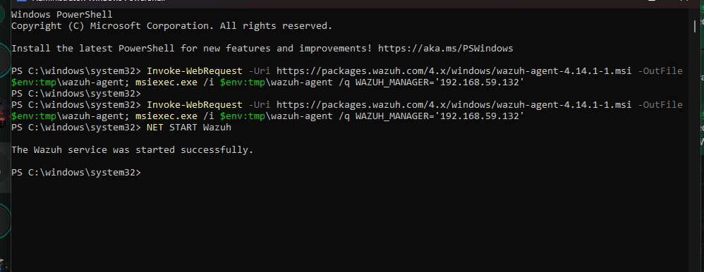
This configuration ensures that unauthorized changes to sensitive files are promptly detected, supporting both security monitoring objectives and compliance requirements such as PCI DSS.

Phase 6: Verifying File Integrity Monitoring in the Wazuh Dashboard
Using a web browser on the Windows host, I access the Wazuh Dashboard and navigate to:
Menu → Endpoint Security → File Integrity Monitoring
By default, the Dashboard tab is displayed. I ensure that the Show dates time range is set wide enough to capture all relevant activities performed during this lab, as time filtering can prevent events from appearing if the range is too narrow.
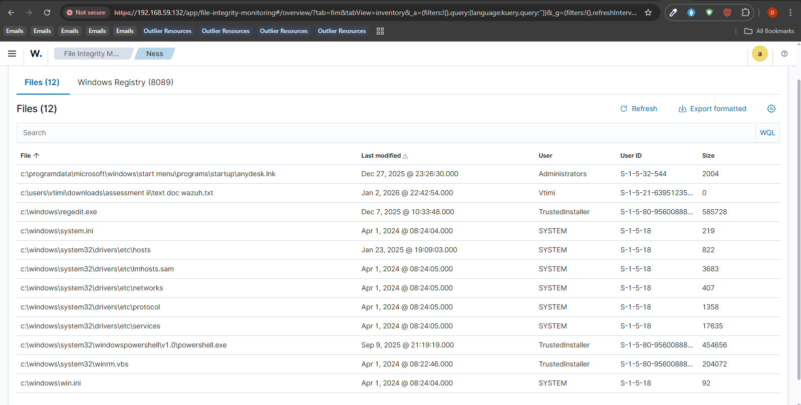
Next, I navigate to the Inventory tab. I select the appropriate Windows agent using the Select agent option (if the agent is not already selected). Once the agent is selected, I search for the monitored file, Text Doc Wazuh txt, and confirm that it appears in the results.
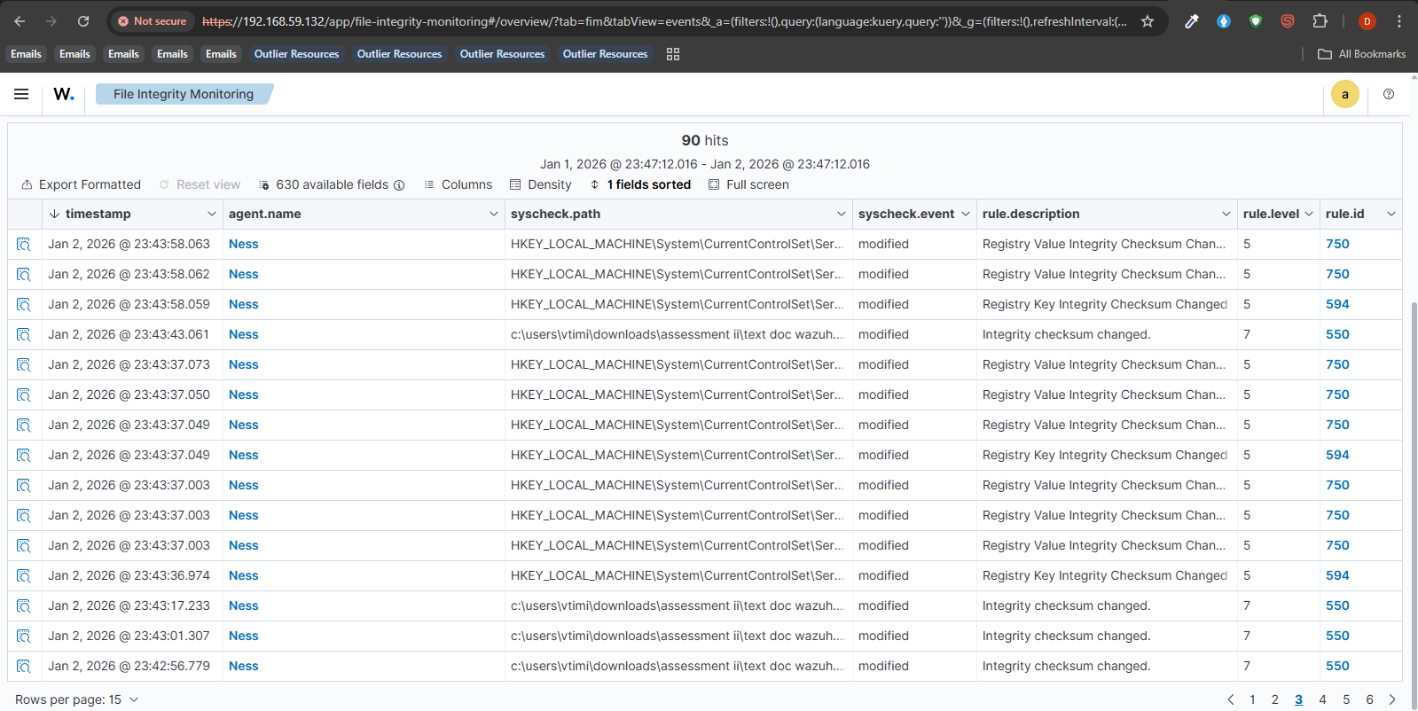
This verifies that the file is successfully being monitored by the Wazuh agent.
To test modification detection, I return to the AssessmentII, folder on the Windows endpoint and open Text Doc Wazuh txt. I add additional text to the file and save the changes.
I then return to the File Integrity Monitoring section of the Wazuh Dashboard, navigate back to the Inventory tab, and search again for ImportantDocument.txt. I select the file from the results, which opens a details panel on the right side of the screen.
Within the details panel, I scroll to the Recent events section and confirm the presence of an event labeled “Integrity checksum changed.” This confirms that Wazuh successfully detects file modifications.
To further validate the alert, I navigate to the Events tab within File Integrity Monitoring and search for:
rule.id: 550
The modified file appears in the results, confirming that file modification events are correctly logged and classified.
To test deletion detection, I return to the AssessmentII folder and delete Text Doc Wazuh txt.
After allowing sufficient time for the agent to perform its system check, I return to the File Integrity Monitoring → Inventory tab in the Wazuh Dashboard and search for the file name again. As expected, the file no longer appears in the inventory, indicating that it has been removed.
I then navigate to the Events tab and search for:
rule.id: 553
The deleted file appears with a “deleted” status, confirming that Wazuh correctly detects and reports file deletion events. If the event does not appear immediately, I verify that the event timestamp is later than the deletion time and wait briefly for the next system scan to complete.
Phase 7: Reviewing General Security Events and Alerts
To review broader security activity, I navigate to the Threat Hunting module by selecting:
Menu → Threat Intelligence → Threat Hunting
The module opens on the Dashboard tab, which provides an overview of detected threats and indicators.
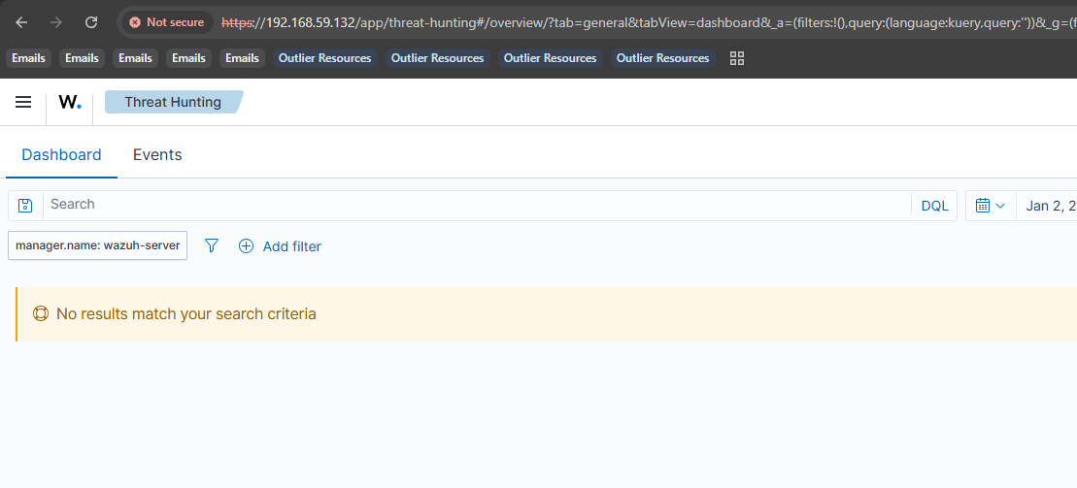
I then navigate to the Events tab, where I can view detailed logs related to suspicious activities, system events, and threat intelligence matches.
These pages provide visibility into overall endpoint security activity and allow for proactive investigation of potential threats.

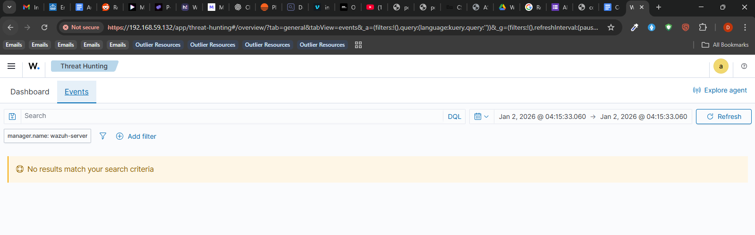
Phase 8: Reviewing GDPR and PCI DSS Compliance
Wazuh automatically maps security alerts to regulatory compliance frameworks when applicable. This allows me to monitor compliance status in real time.
From the Wazuh Dashboard, I open the menu and navigate to:
Security Operations → PCI DSS
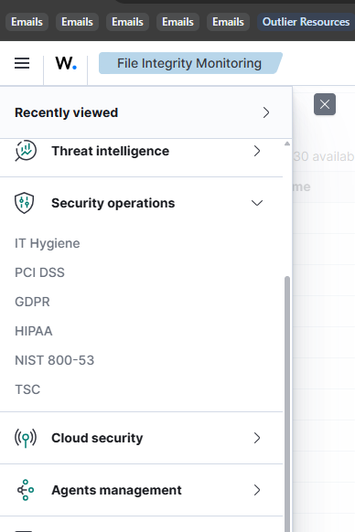
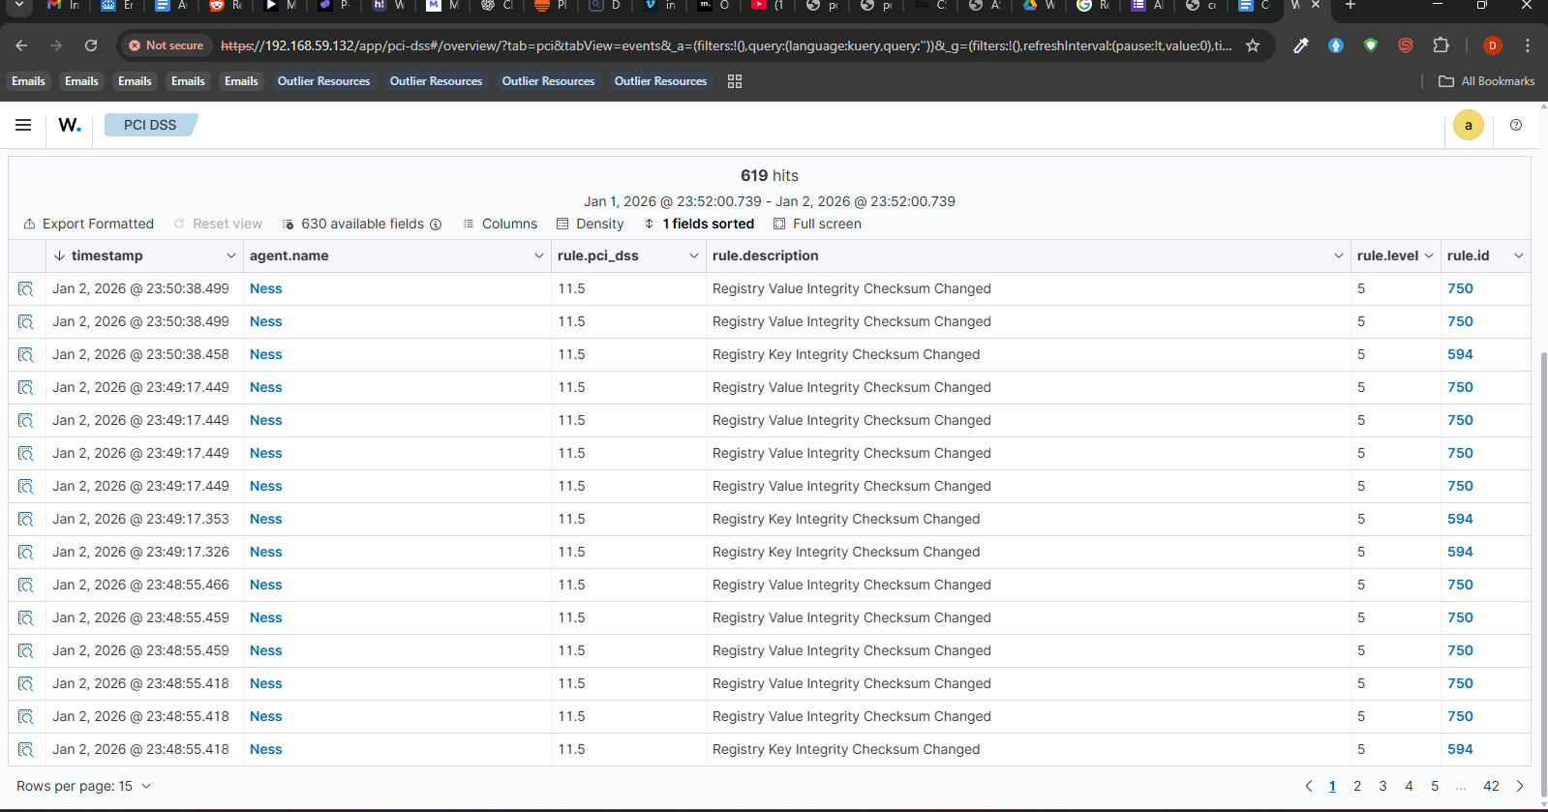
The PCI DSS dashboard displays a summary of compliance requirements, highlighting which controls are met or violated based on recent alerts. This view is especially useful for monitoring systems that handle payment card data and demonstrating compliance to auditors.
I then navigate to:
Security Operations → GDPR
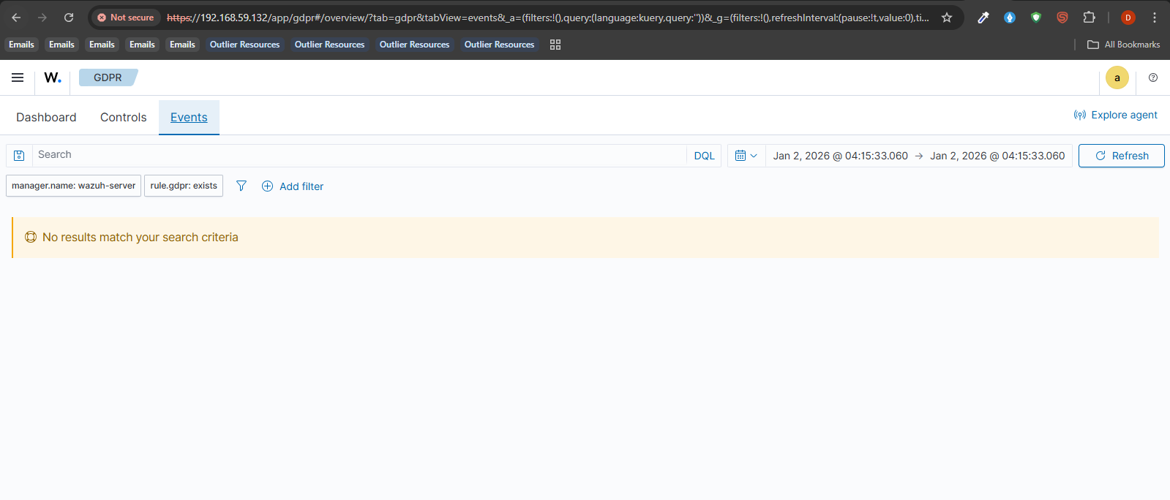
This dashboard maps security events to relevant GDPR articles, providing insight into data protection and privacy-related risks. The GDPR dashboard helps identify potential violations related to personal data handling and access control.

